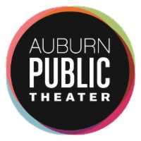

Dear Patrons & Friends of Auburn Public Theater,

We are ecstatic to announce that we have reopened with limited in-person programming for the fall of 2021 and winter of 2022. Our team is working to honor our commitment to keeping the community healthy and safe while honoring the wishes of visiting artists.

Patrons of ticketed Main Stage events and public events should plan to arrive at Auburn Public Theater at least 20 minutes early, and, prior to entering the theater, find our COVID-19 checkpoint table.

Vaccinated patrons are required to show proof of full vaccination. Unvaccinated patrons must show proof of a recent negative COVID-19 test.

All patrons are expected to wear masks inside the theater, especially when social distancing is not possible. Patrons may briefly remove their masks to eat or drink.

Please note that Auburn Public Theater will not offer on-site testing. If you require assistance scheduling a test, please contact the Cayuga County Health Department at 315-253-1560.

Please feel free to reach out to us if you have any questions, concerns, suggestions. And as always, thank you for your support and for being a valued member of our community. We appreciate your understanding and cooperation, and we can’t wait to see you back in the theater!

The Staff of Auburn Public Theater

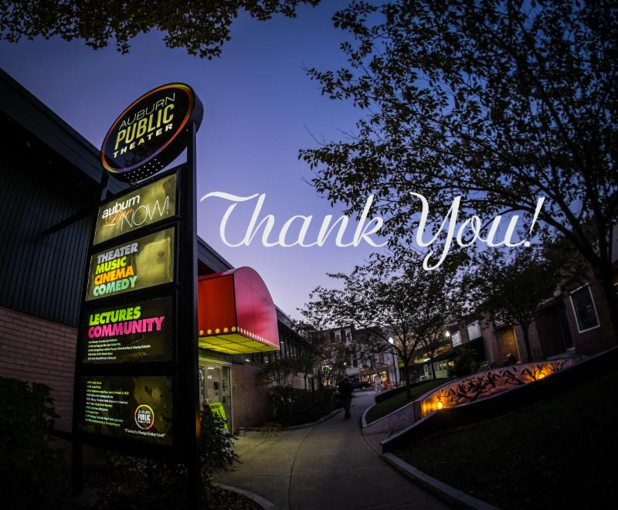
Check out our upcoming live events HERE!
Or our continuing online events HERE!

A NOTE ON PREVIOUSLY SCHEDULED EVENTS:
Some previously scheduled performers will not be performing during our fall/winter season, and we have been working with them to find new dates in the spring of 2022. We will let you know as soon as we have those dates through our email newsletter, on our Facebook page, and here on our website. All previously purchased tickets will be honored for the new dates.

